**Installation and Navigation of Visual Studio Code (VS Code)**

**Instructions**:

1. **Installation of VS Code**:

> First go to Microsoft store and search for VS code

> Click on get to download installer package

> click on install after package finishes downloading

1. **First-time Setup:**

> Use 'Ctrl +,' to open settings to configure your preferred settings, such as font size, theme, tab size, and more

> While in settings configure terminal and set Git bash as default

> on your mid left side, click on extensions download useful extensions like Prettier, Gitlens, Python, Docker and more

1. **User Interface Overview:**

> VS code has a polished and well-structured user interface designed to maximize productivity

> Active bar - located on the left side of the window, allows you to manage different views and extensions

> Side bar - located on the right of the activity bar, provides contextual information and controls for the selected activity from the Activity Bar

> Group editor - located in the middle of the window and it can split the editor into multiple groups to view different files side by side

> Status bar - located on the bottom of the window, provides information about the current state of the editor and workspace

1. **Command Palette:**

> Command Palette - Tool that allows you to execute various commands, search for features, and access settings without navigating through the menus

> can be accessed by 'Ctrl + Shift + P'

> Command Palette can be used to open file or folder, search across files, formatting code actions etc

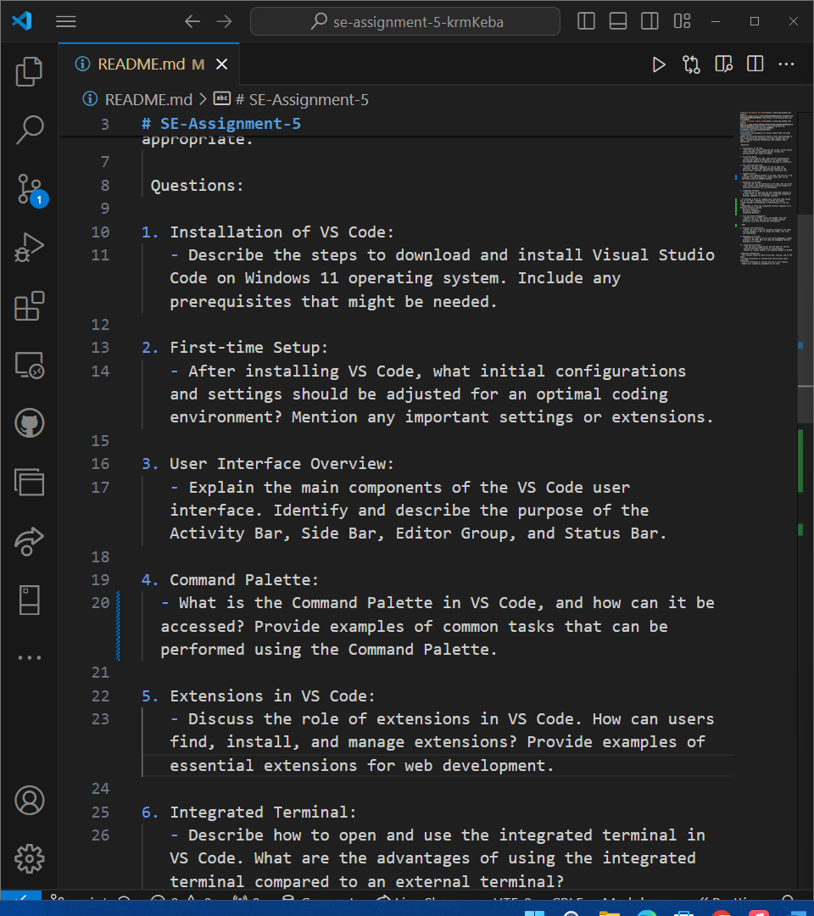



1. **Extensions in VS Code:**

> Expands the functionality of VS Code, making it adaptable to various programming languages, frameworks, and development workflows

> Find extensions by browsing them on the extension slot on your left

> Click on the extension card to view and download extensions

> Extensions Automatically updates them self’s





1. **Integrated Terminal:**

> It provides a built-in command-line interface that allows you to run shell commands directly within the editor

> Open terminal by navigating to View/Terminal in the top manue

> Advantages of Using the Integrated Terminal Compared to an External Terminal include:

Multiple Terminals

Extension Integration

Integrated Workflow

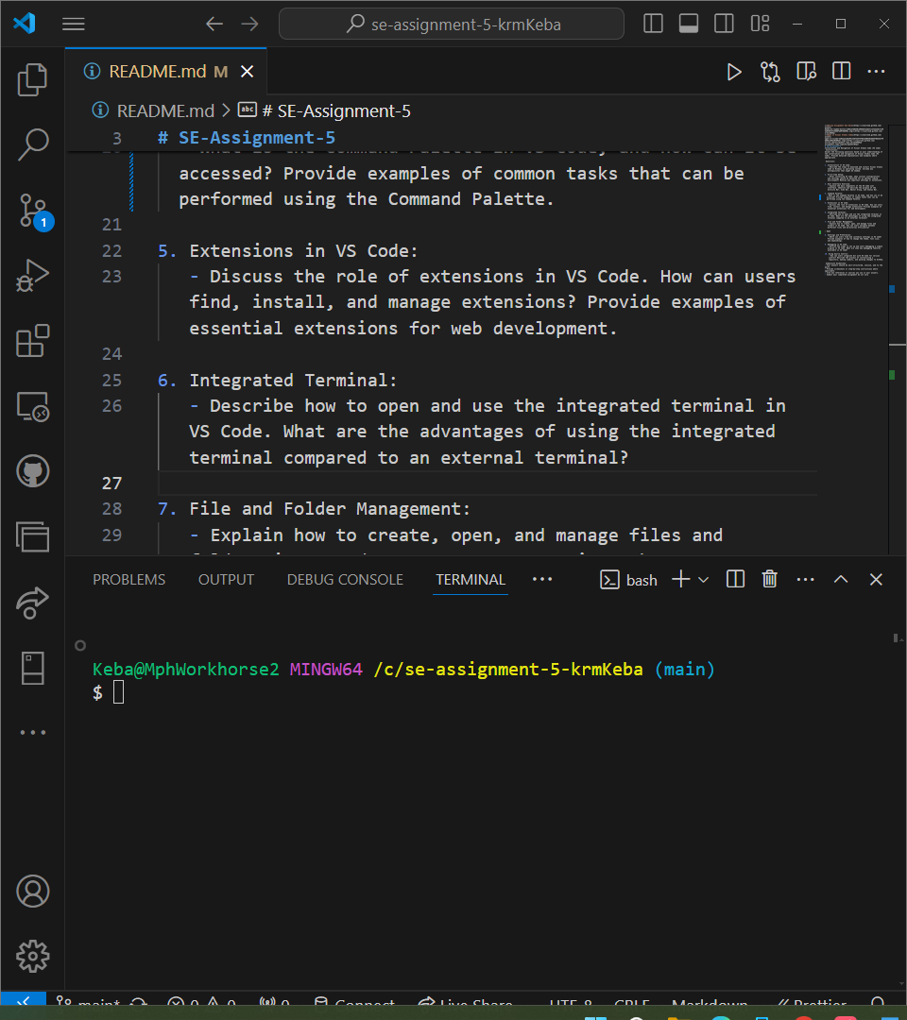



1. **File and Folder Management:**



8. **Settings and Preferences**

> Access setings by Navigating to File/Preferences/Settings

> Open the Settings UI to explore changing theme, font sixe and key bindings

**9. Debugging in VS Code:**

**>** Open the Run and Debug View

**>** Create a Debug Configuration and Select the appropriate environment. For Python, choose Python File

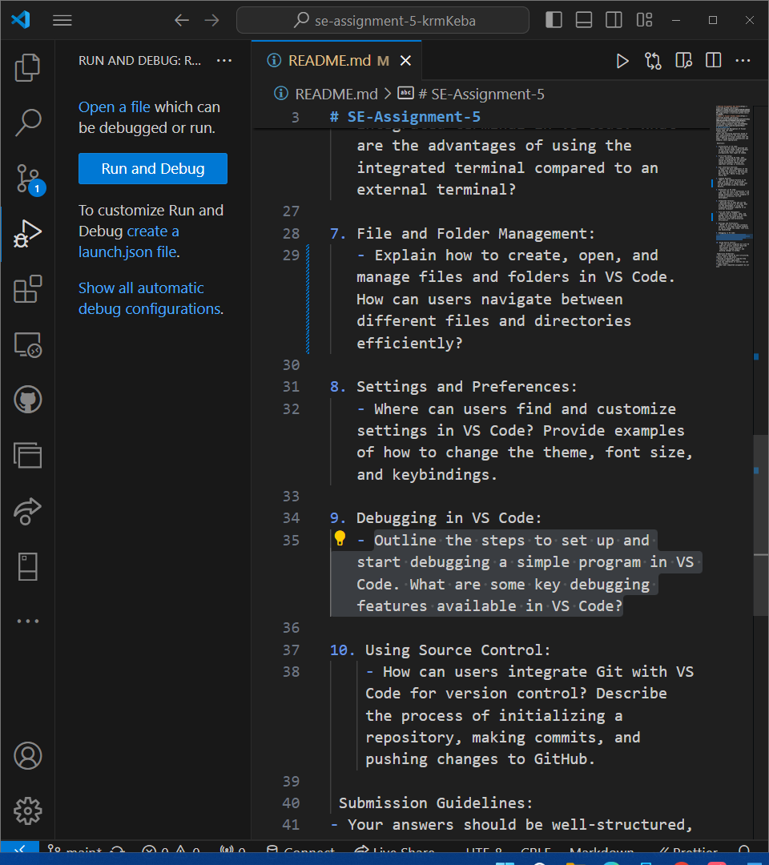



**10. Using Source Control:**

**>** Integrating Git with VS Code for version control is a powerful way to manage your source code efficiently

**>** Open your project folder, Initialize the repository by Open the Source Control view and Click on Initialize Repository or the Initialize button to create a new Git repository in the opened folder

**>** Open Git Bash and execute the following commands:

*- git init*

*- git add .*

*- git commit -m "Your commit message"*

> Create a repository on GitHub and Copy the repository URL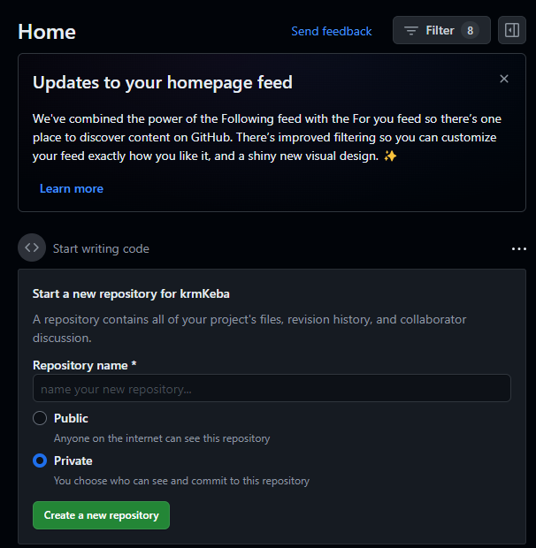



**>** Add the remoterepository and Push your changes using the following commands on gitbash:

**-** *git remote add origin* [*https://github.com/your-username/your-repository.git*](https://github.com/your-username/your-repository.git)

*- git push -u origin main*